Assignment #1 – AI-Based Application Development in .NET (Theory)

1. Introduction to AI-Based Applications

What is Artificial Intelligence?
Artificial Intelligence (AI) is a technology that enables machines and software to perform tasks that normally require human intelligence. These tasks include understanding language, recognizing images, making decisions, and learning from data.
In simple words, AI allows computers to “think” and “learn” instead of just following fixed instructions.

What are AI-Based Applications?
AI-based applications are software systems that use artificial intelligence to provide smart and automated solutions. These applications can analyze data, understand user input, and generate intelligent outputs.
Instead of giving fixed results, AI applications adapt and improve based on data and user interaction.

Real-World Examples
- Chatbots – Answer user questions (e.g., customer support bots)
- Recommendation Systems – Suggest products or videos (like YouTube or Netflix)
- Image Recognition – Detect faces or objects in images
- Voice Assistants – Understand and respond to voice commands

2. AI in .NET Ecosystem

How AI is Integrated in .NET
The .NET platform supports AI development in two main ways:
- Using built-in machine learning libraries
- Connecting with external AI services through APIs
This makes it easy for developers to build AI-powered applications using C#.

ML.NET
ML.NET is a machine learning framework developed by Microsoft for .NET developers.
- It allows building AI models directly inside .NET applications
- No need to switch to other languages like Python
- Used for tasks like prediction, classification, and data analysis

REST APIs for AI Services
Instead of building models from scratch, developers can use external AI services.
These services are accessed using APIs (Application Programming Interfaces). For example:
- Sending a text to an AI service
- Receiving a generated response
This approach is faster and easier for beginners.

Benefits of Using .NET for AI
- Easy integration with C# applications
- Strong support from Microsoft
- Good performance and scalability
- Large developer community

3. AI Application Development Lifecycle
Developing an AI application follows a step-by-step process:

1. Problem Identification
First, we define the problem we want to solve.
Example: “Build a chatbot that answers user questions.”

2. Data Collection
Data is collected based on the problem.
This data is used to train the AI model.

3. Data Preprocessing
The collected data is cleaned and organized.
This step removes errors and prepares data for training.

4. Model Selection
A suitable AI model or approach is selected depending on the problem.

5. Model Training
The model learns patterns from the data.
This is where the “intelligence” is developed.

6. Model Evaluation
The model is tested to check its accuracy and performance.

7. Integration with Application
The trained model or API is connected with the application (e.g., a .NET app).

8. Deployment
The final application is deployed so users can access it.
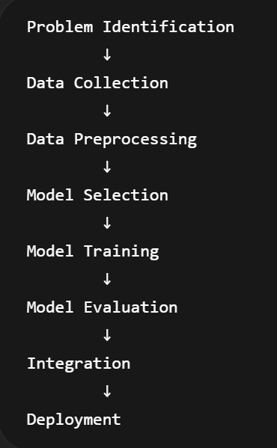

4. Architecture of an AI-Based Application
An AI-based application is usually divided into different parts:

Frontend (User Interface)
This is the part the user interacts with.
Examples: Windows Forms or Web Interface.

Backend (.NET Logic)
This handles the main application logic, such as processing input and sending requests to AI services.

AI Model / API
This is the intelligence part.
It processes input and generates smart output.

Database (Optional)
Used to store user data, history, or application data.

Basic Workflow
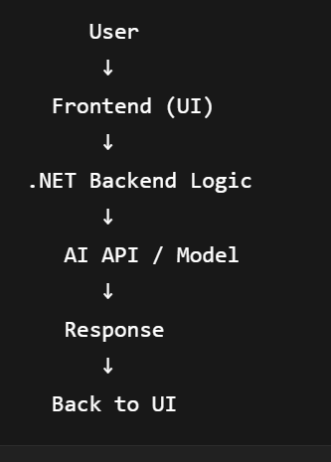
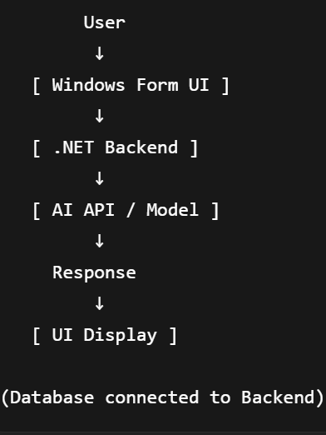

5. API Integration Concept

What is an API?
An API (Application Programming Interface) is a way for different software systems to communicate with each other.

How AI APIs are Used
In AI applications:
- The app sends a request (input data) to the API
- The API processes it using AI
- The API returns a response

Request/Response Flow
- User enters input
- Application sends request to API
- API processes data
- API returns response
- Application displays result

6. Introduction to Docker

What is Docker?
Docker is a tool used to package applications and their dependencies into a container.
A container ensures the application runs the same way on any system.

Why Docker is Used
- To avoid environment issues
- To make applications portable
- To simplify deployment

Benefits of Docker
- Portability – Run anywhere
- Consistency – Same behavior on all systems
- Isolation – No conflicts with other software

7. Version Control using GitHub

Importance of GitHub
GitHub is used to store and manage code online.
It helps developers:
- Track changes
- Collaborate
- Backup their work

Basic Workflow
- Repository Creation – Create a project repository
- Commit – Save changes
- Push – Upload changes to GitHub

README File
A README file explains the project, including:
- Description
- Setup instructions
- Screenshots

8. Ethical Considerations

Bias in AI
AI systems can produce biased results if trained on biased data.

Data Privacy
User data must be protected and not misused.

Responsible AI Usage
AI should be used in a safe and ethical way, avoiding harm or misuse.

Conclusion
AI-based application development in .NET combines modern artificial intelligence techniques with powerful software development tools. By understanding the lifecycle, architecture, and integration methods, developers can build smart and efficient applications. Tools like Docker and GitHub further improve deployment and collaboration, making the development process more professional and reliable.

